# Session 3 – EXERCISES

# Exercise One – Simple problem-solving using the HIRAC method

Jamie in interested in motorbikes. She speaks to Henry who is something of a motorbike enthusiast. Henry says he has more motorbikes than he knows what to do with and that he would be happy to sell Jamie his Yamaha bike for $1,000. Jamie says she wants to think about it and will get back to Henry shortly.

The weekend arrives and Henry plans to go to a new and used motorbike expo. He decides that this would be a good opportunity to get rid of some of his excess bikes so he loads them all onto a truck, including the Yamaha he offered to Jamie. On his way to the expo, he remembers about his offer to Jamie so gives her a call on his mobile phone. When she answers, he says:

*“Jamie, I didn’t hear back from you on the Yamaha. So I’ve decided to take it to the motorbike expo and sell it there instead, along with some other bikes. I’ll probably get a premium price, expos are like that!”*

Jamie expresses dismay and says:

“*Oh really? But I do want to buy it! I was planning to call you today to say I’d take it!”*

Henry replies:

*“Sorry Jamie – I’m on my way to the expo already and I really am better off selling the bike there. “*

In the case of *Left v Right,*[1]the High Court held in a unanimous judgment:

A binding contract arises between two parties when party A makes an offer which is accepted unconditionally by party B (and various other requirements are satisfied). Once accepted, the offer cannot be withdrawn. However, until such time as the offer has been accepted, it is open to party A to revoke or withdraw that offer, after which time party B cannot accept it and no binding contract based on that offer is able to be formed.

**Is there a binding contract between Henry and Jamie?** (Note: Assume that the ‘various other requirements’ referred to by the High Court in *Left v* Right have been satisfied here)

# Exercise Two – Advanced problem-solving using the HIRAC method

*This exercise requires you to tackle more nuanced aspects of legal problem solving. In particular, it enables you to practice reading a judgment and working out its most important parts (especially the legal principles for which is stands) and then using that judgment to assist you to advise on a new set of facts using the HIRAC method. It is still somewhat ‘artificial’ because you are told to refer to only one case in your analysis (in real life, a number of cases may be relevant). Nonetheless, it will require more sophisticated analysis than was needed in Exercise One.*

***It is essential that before Session 3 you have:***

* *read this question (including the case) carefully; and*
* *thought about the essential principles established by the case (ie the ratio(nes) decidendi).*

*You don’t need to prepare an answer to the problem itself – that is what we will workshop in our small groups and as a class (although if you want to come prepared with some dot points to guide you in your small groups discussion, please do so - it will always help).*

# Problem scenario:

Andrew and Marilyn are neighbours and good friends. Andrew owns a bookstore in Canberra which sells both new and used books. One of Marilyn’s great hobbies is reading. She also loves going to garage sales and deceased estate auctions on the weekends, at which she always buys used books.

Marilyn has become familiar with the sorts of books that Andrew likes to resell in his bookstore. Marilyn often goes over to Andrew’s house on a Sunday evening for a drink and to show him her most recent used book purchases. Andrew often takes the whole lot off her hands for $100 and resells them in his store.

One Sunday evening Marilyn goes over to Andrew’s house as usual with her books, but finds that he is not home (he had decided to visit his sister for a few days in Queensland). However, he has stuck the following note on his front door:

*If you leave your books in the trunk outside my back door, I’ll pay you the $100 later.*

*Cheers*

*Andrew*

Marilyn takes the note and goes around the back of the house and sees the trunk. She removes the lid and, seeing that the trunk is empty, puts her books inside and replaces the lid.

Later in the week, Marilyn looks out the window and sees that Andrew is back. She goes over and they chat about his trip. Andrew informs Marilyn that his sister is gravely ill and he has decided to close down his bookstore so he can move to Queensland to care for her. Marilyn is saddened by the news but decides to ask for the $100 for her used books anyway. Andrew says “I didn’t know you’d left any books”. Marilyn replies: “I put them in the trunk by your back door, just as you’d told me to do on your note.” They both go to check the trunk and find the books. Andrew refuses to pay Marilyn the $100, saying he doesn’t want the books anymore because he is closing his bookstore.

# Question:

With reference ONLY to *Carlill v Carbolic Smoke Ball Co*. [1893] 1 QB 256 indicate whether there is an enforceable promise by Andrew to pay Marilyn $100 for the books.

*Carlill v Carbolic Smoke Ball Co*. is reproduced below, starting on the next page.

PLEASE NOTE:

* *Carlill v Carbolic Smoke Ball Co* is a famous contract law case but also very old and you may find parts of it difficult. Don’t be concerned if it takes you a while to absorb it; or if there are parts that remain unclear – we can discuss these in class. Note that the judges’ reasons start on page 261 (Lindley LJ). The preceding pages record the facts and summarise the legal arguments put to the Court by the parties’ legal counsel.
* In discussing the answer in your small groups, aim to follow the HIRAC method. You won’t have time to write out an answer in full – rather use your discussion to workshop ideas and prepare a bullet point answer plan.
* In your own time – ideally after this session – you might like to have a go at ‘writing up’ the answer in full. This will be relatively straightforward, in that you will already have worked through the structure in class. However, it will deepen your insight into how a problem question answer comes together and how all the distinct points can be woven effectively into a coherent whole. This is the best possible preparation you could have for the problem question assessment task in our course and for similar tasks in many of your future law courses.

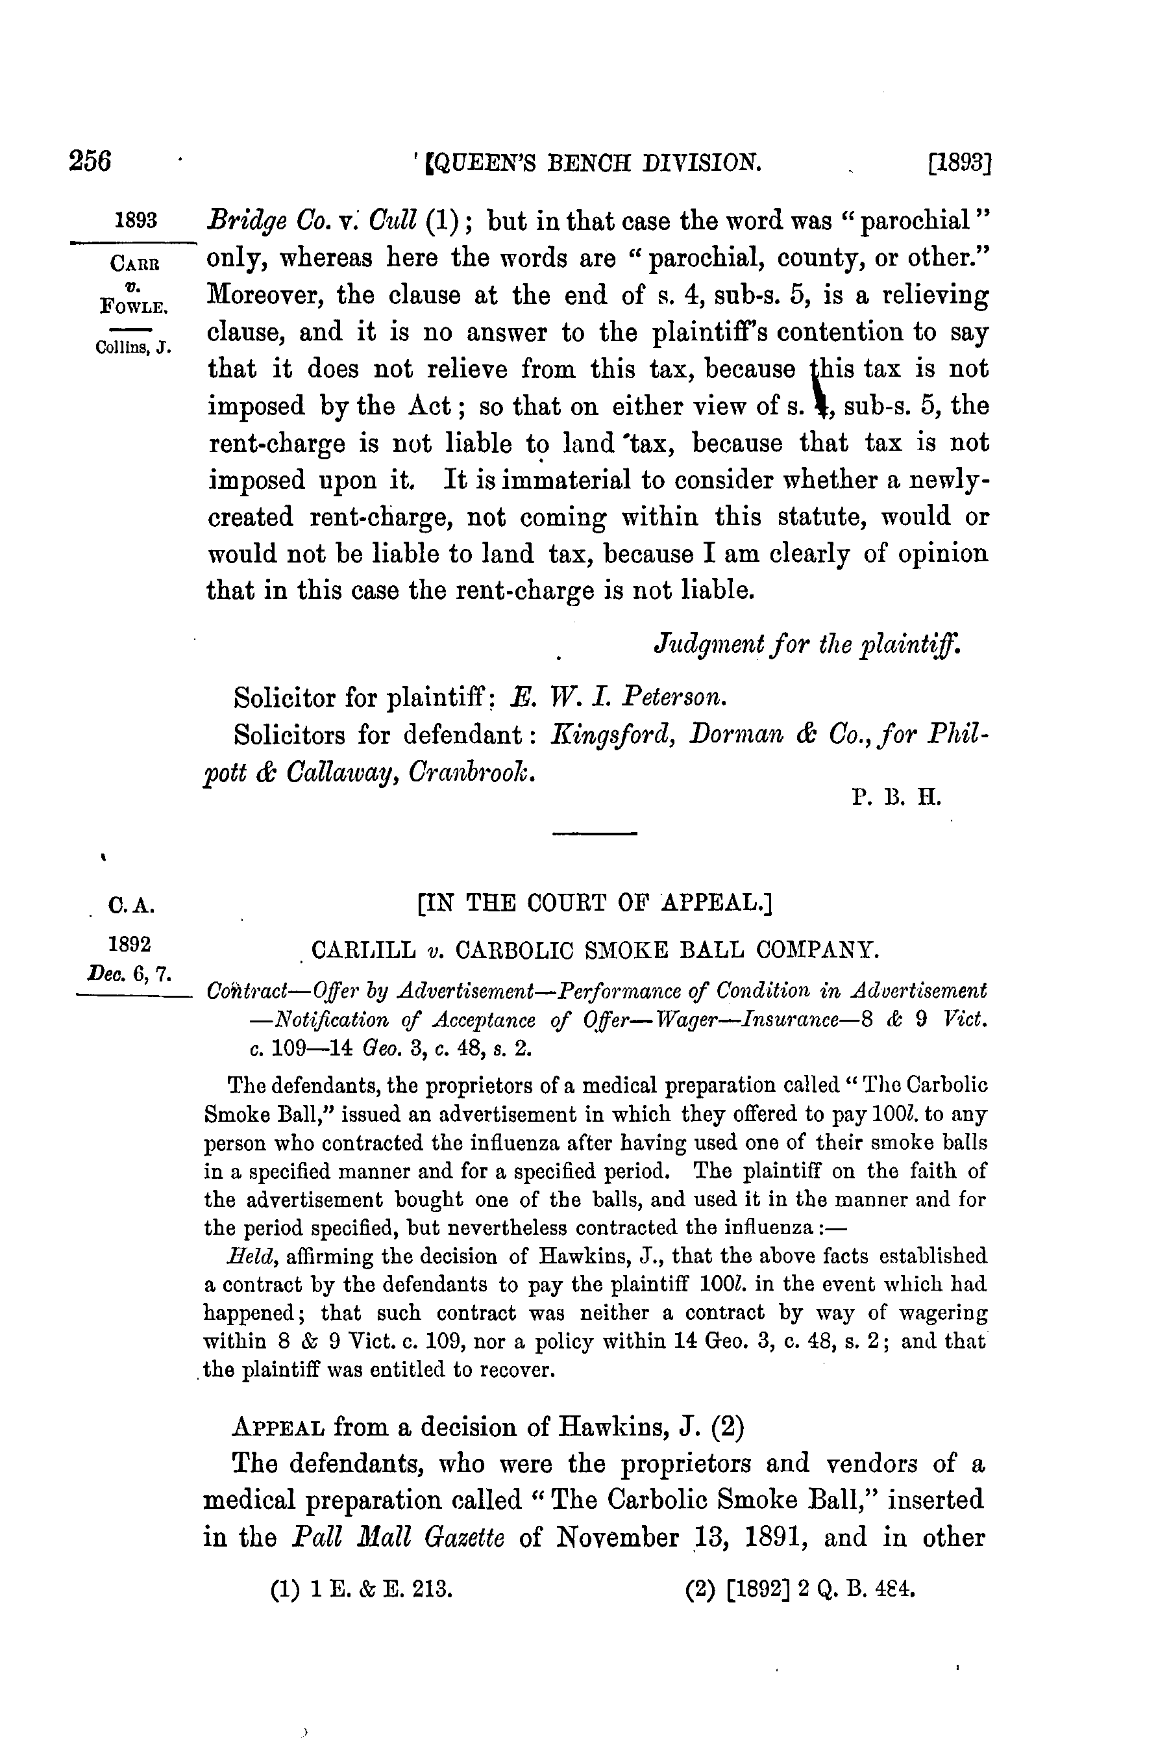

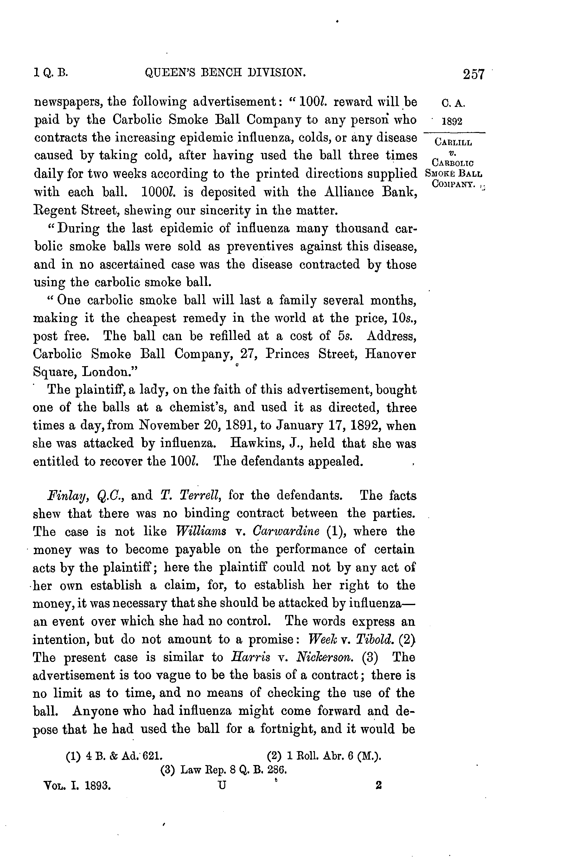

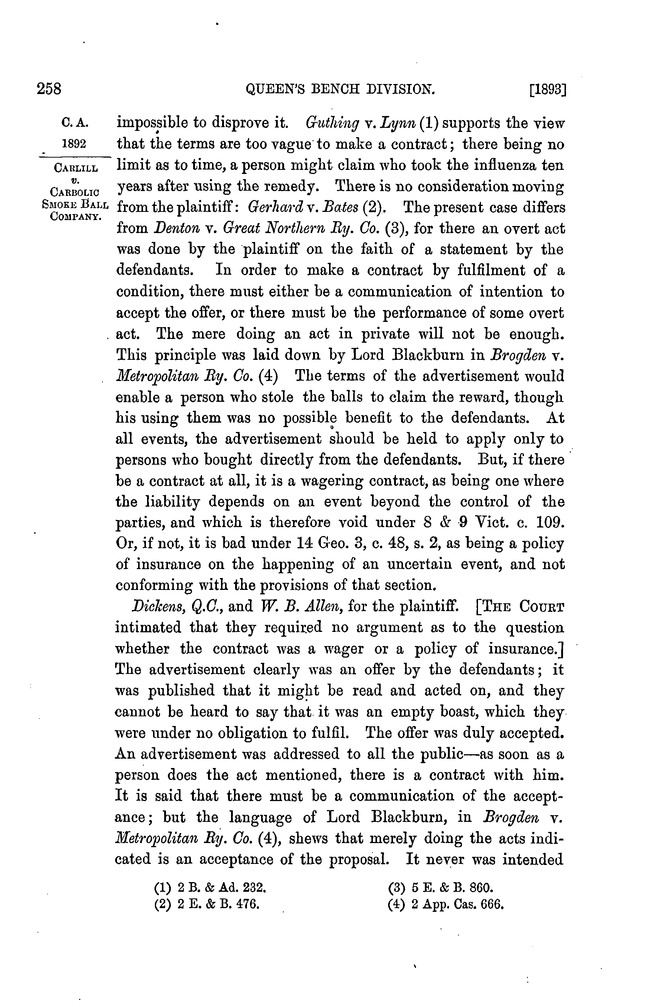

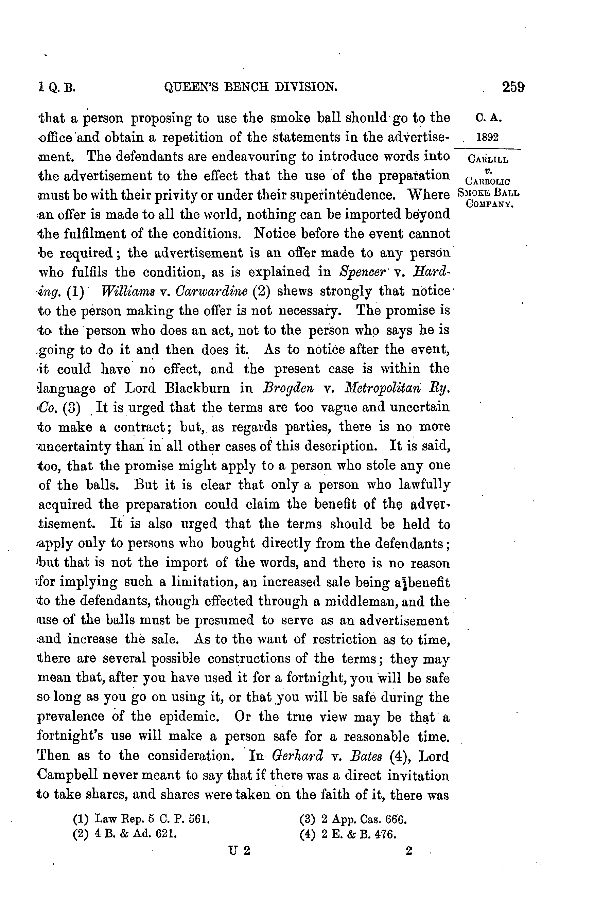

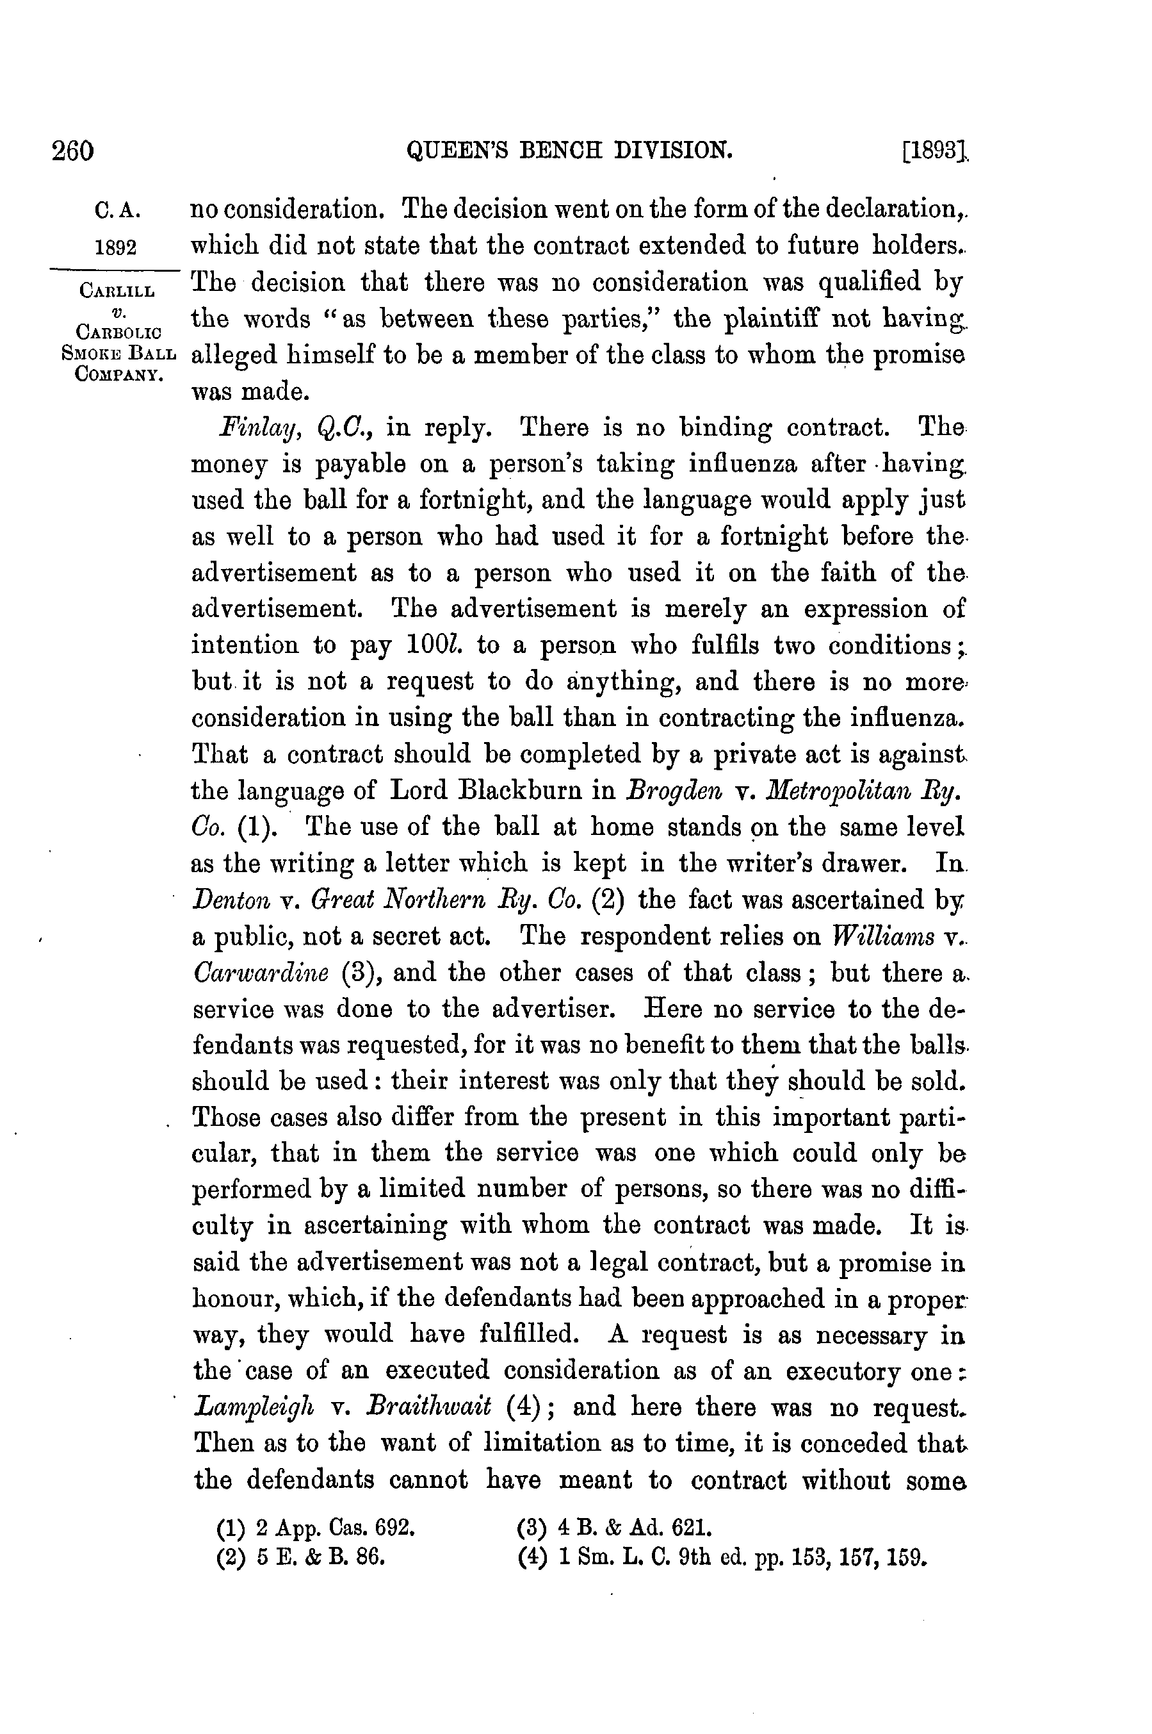

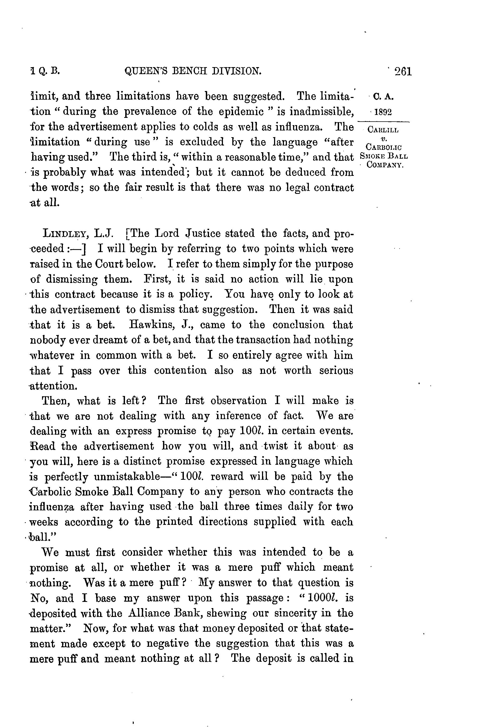

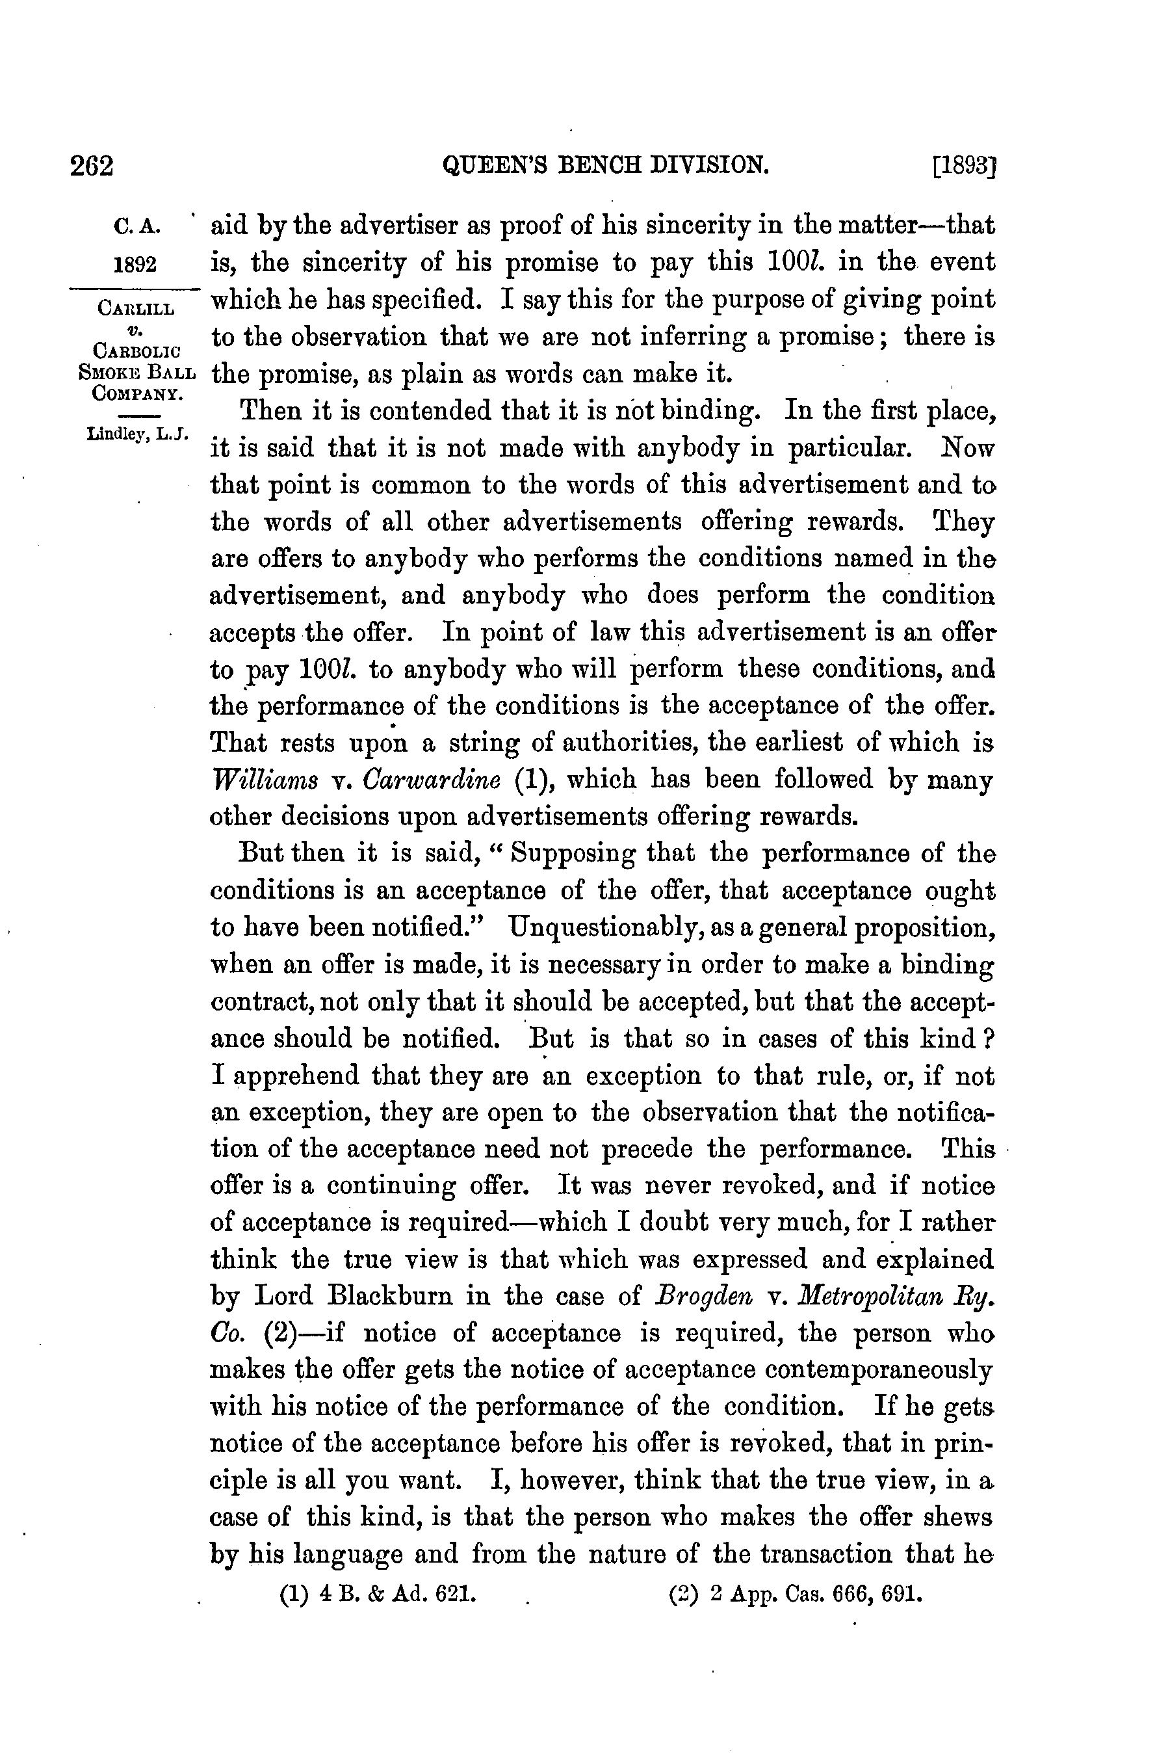

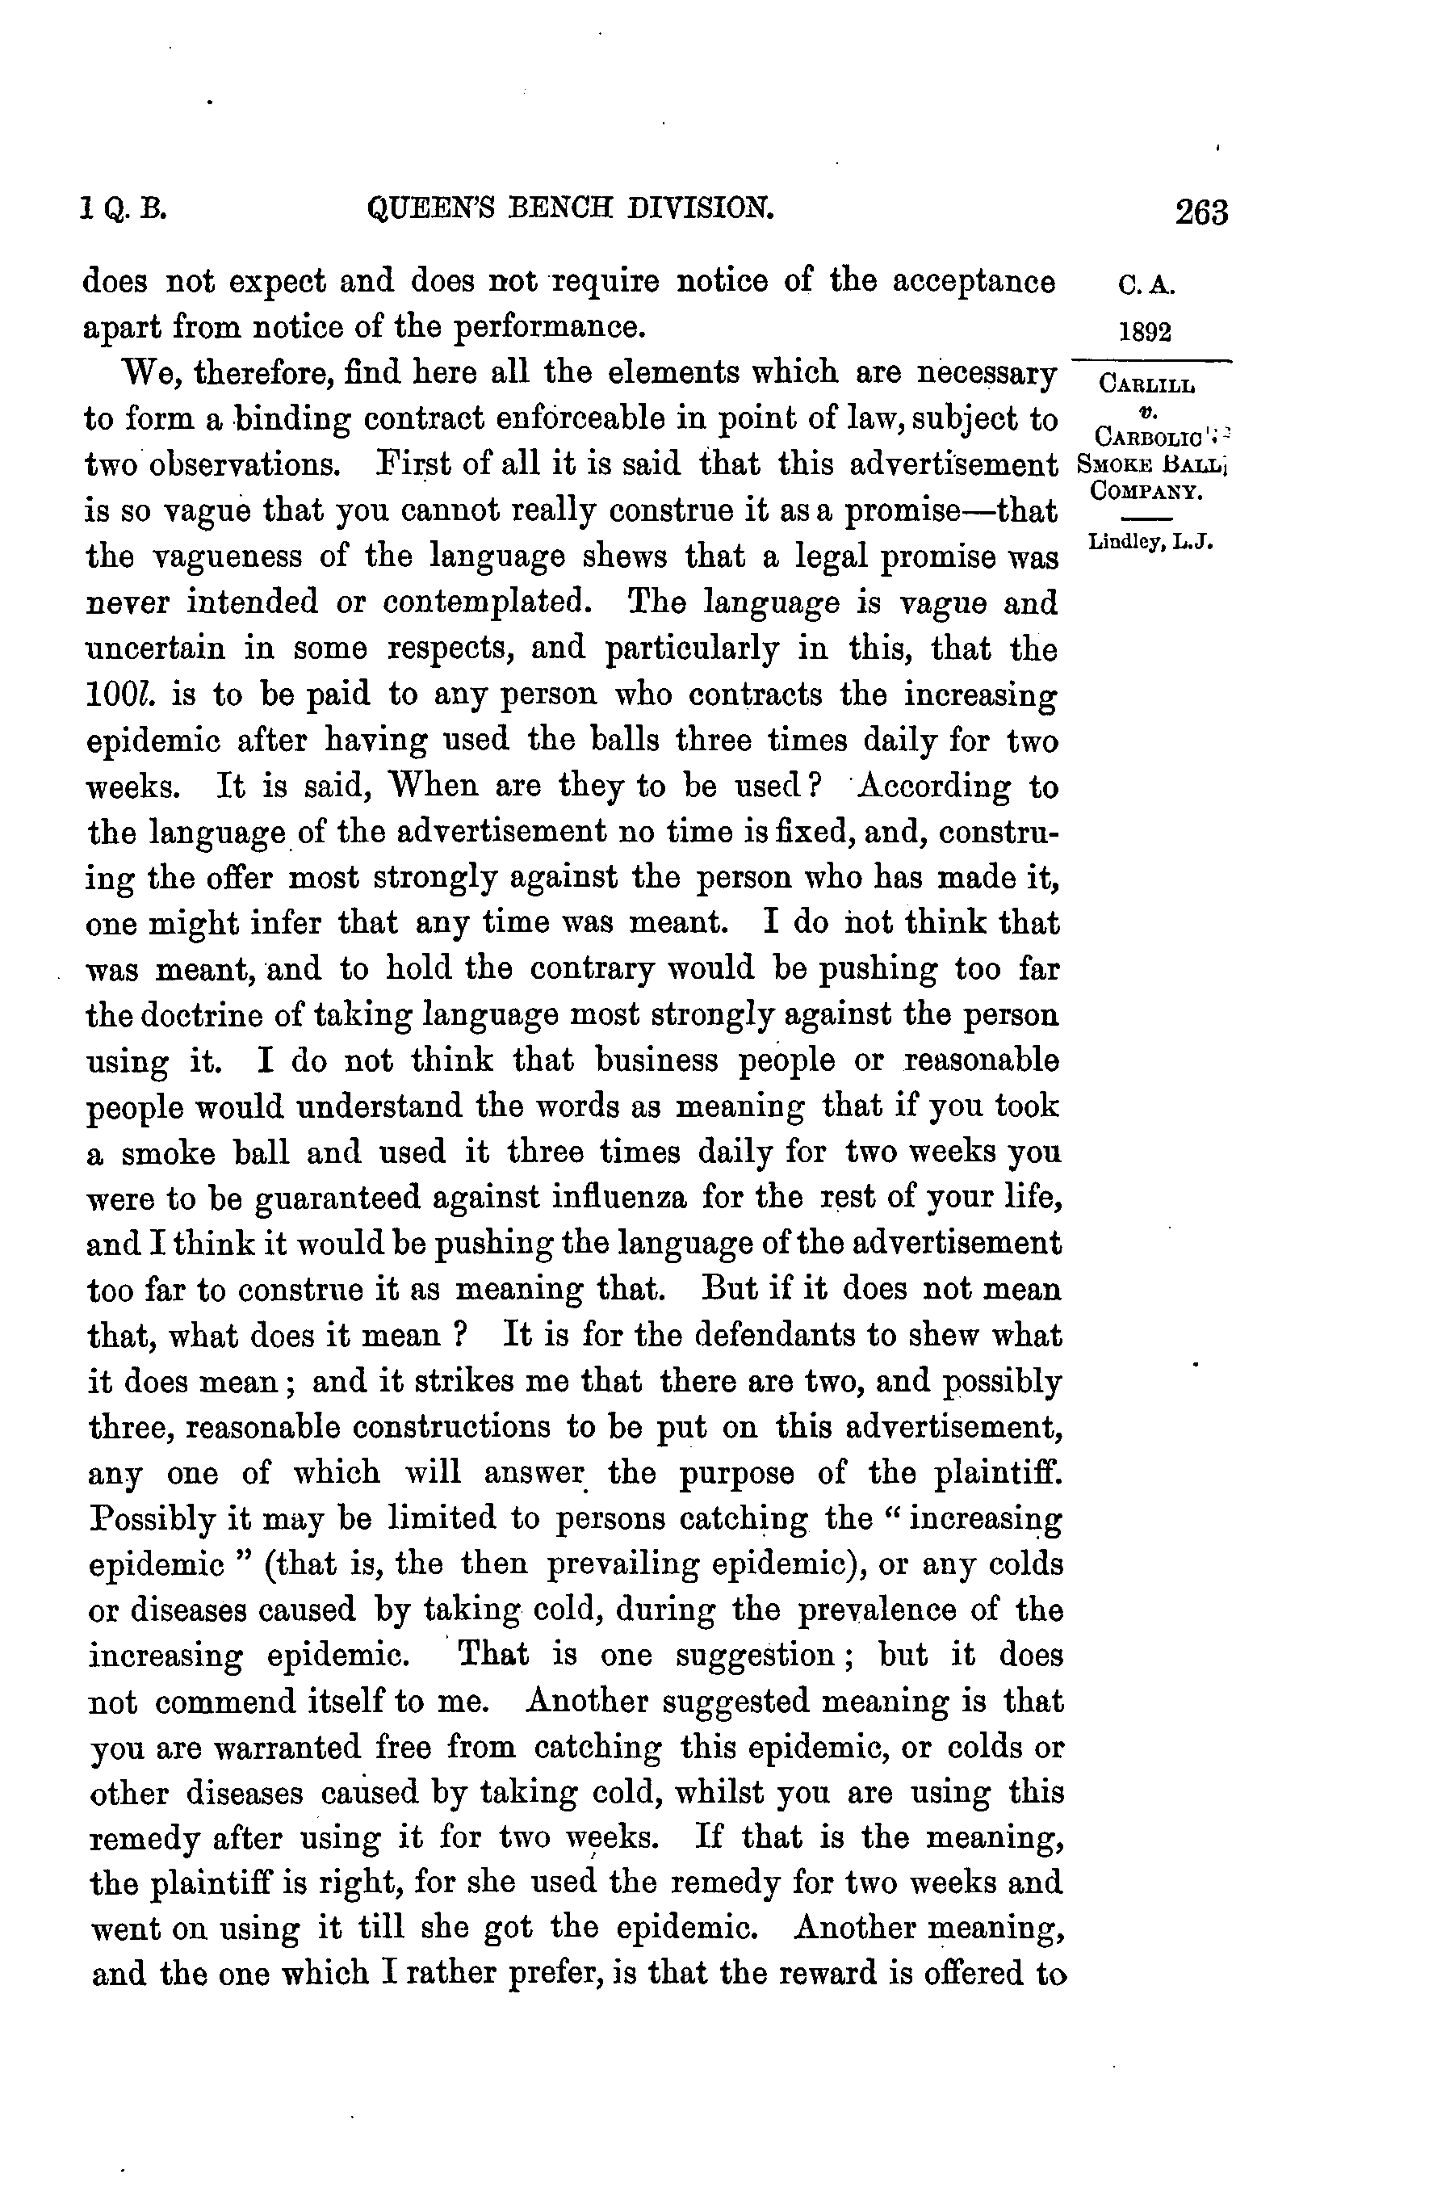

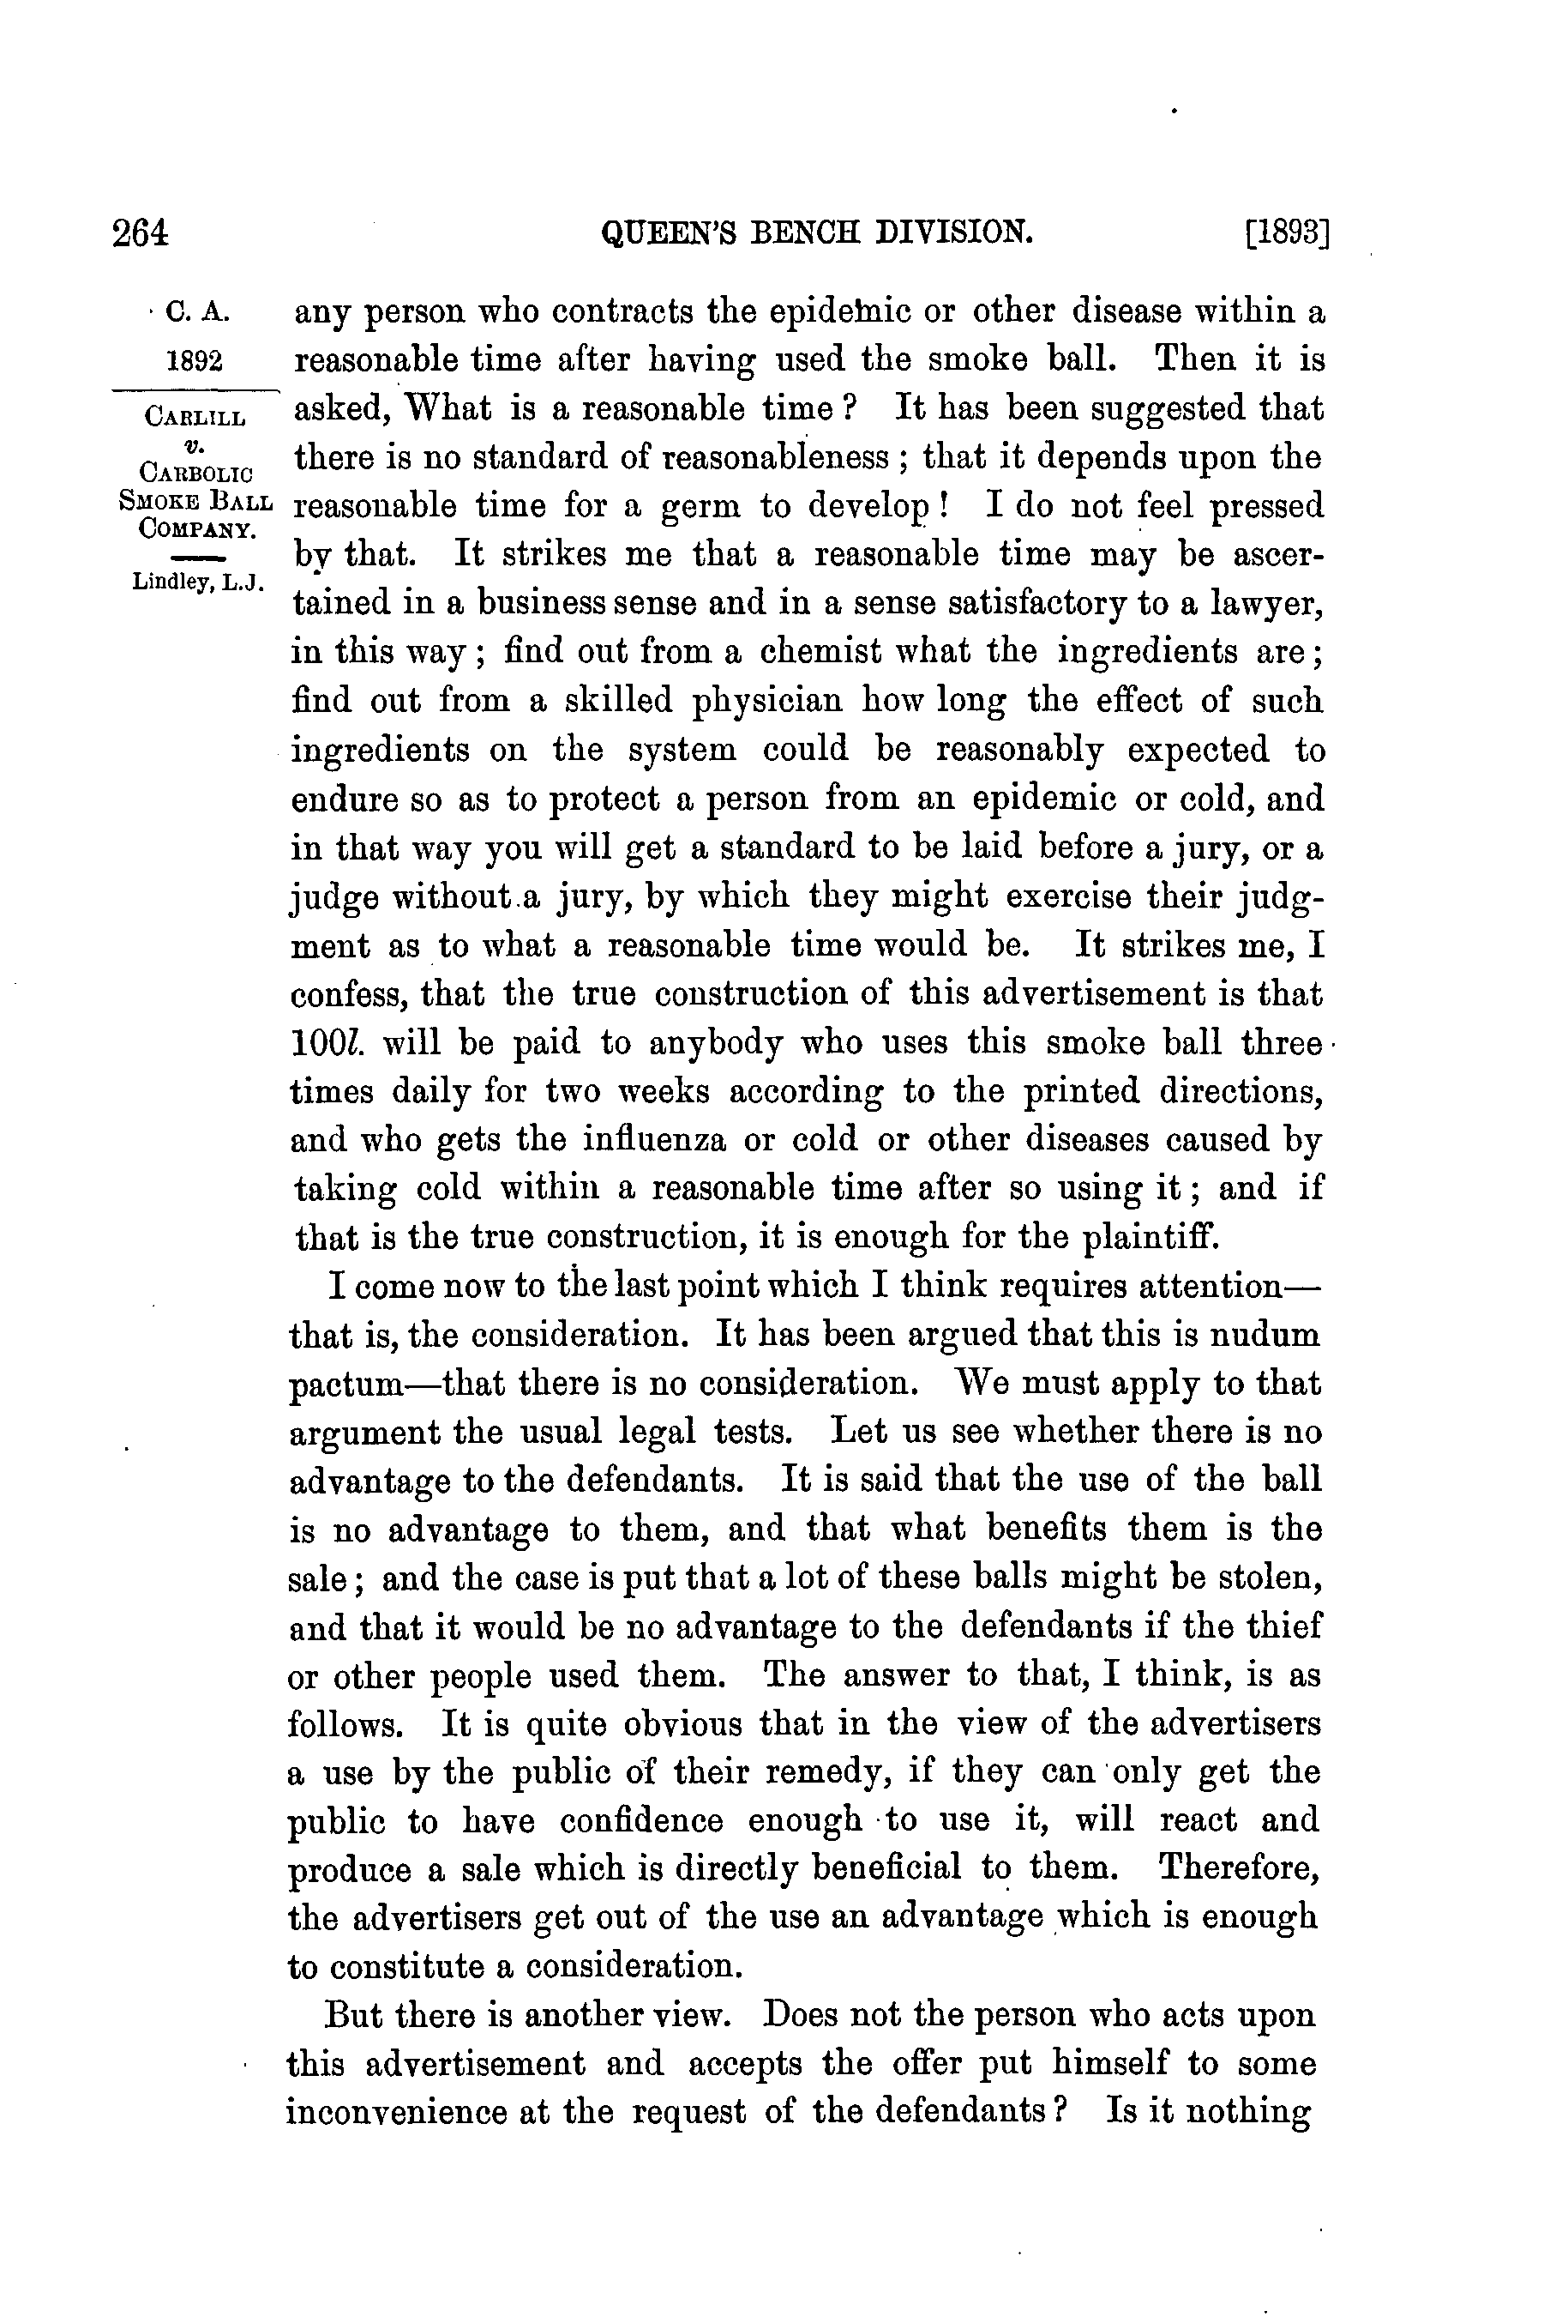

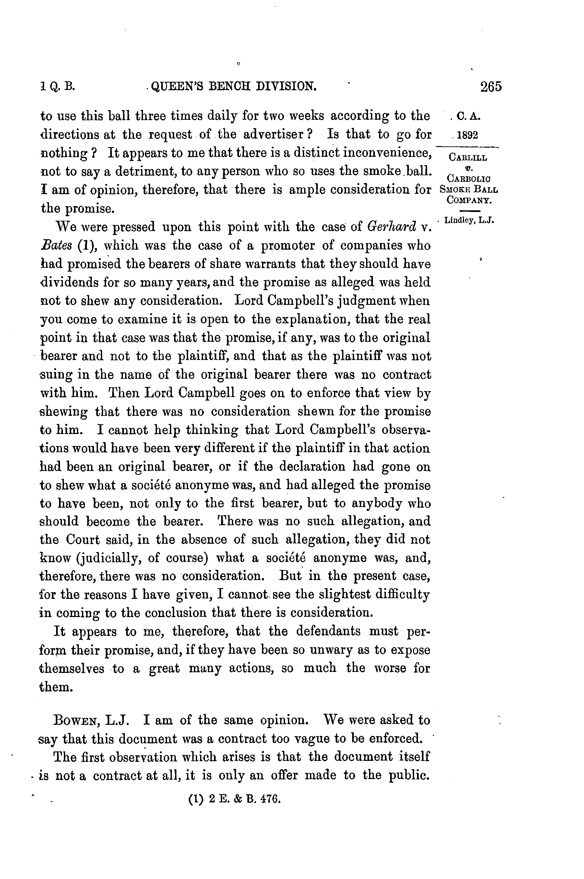

'

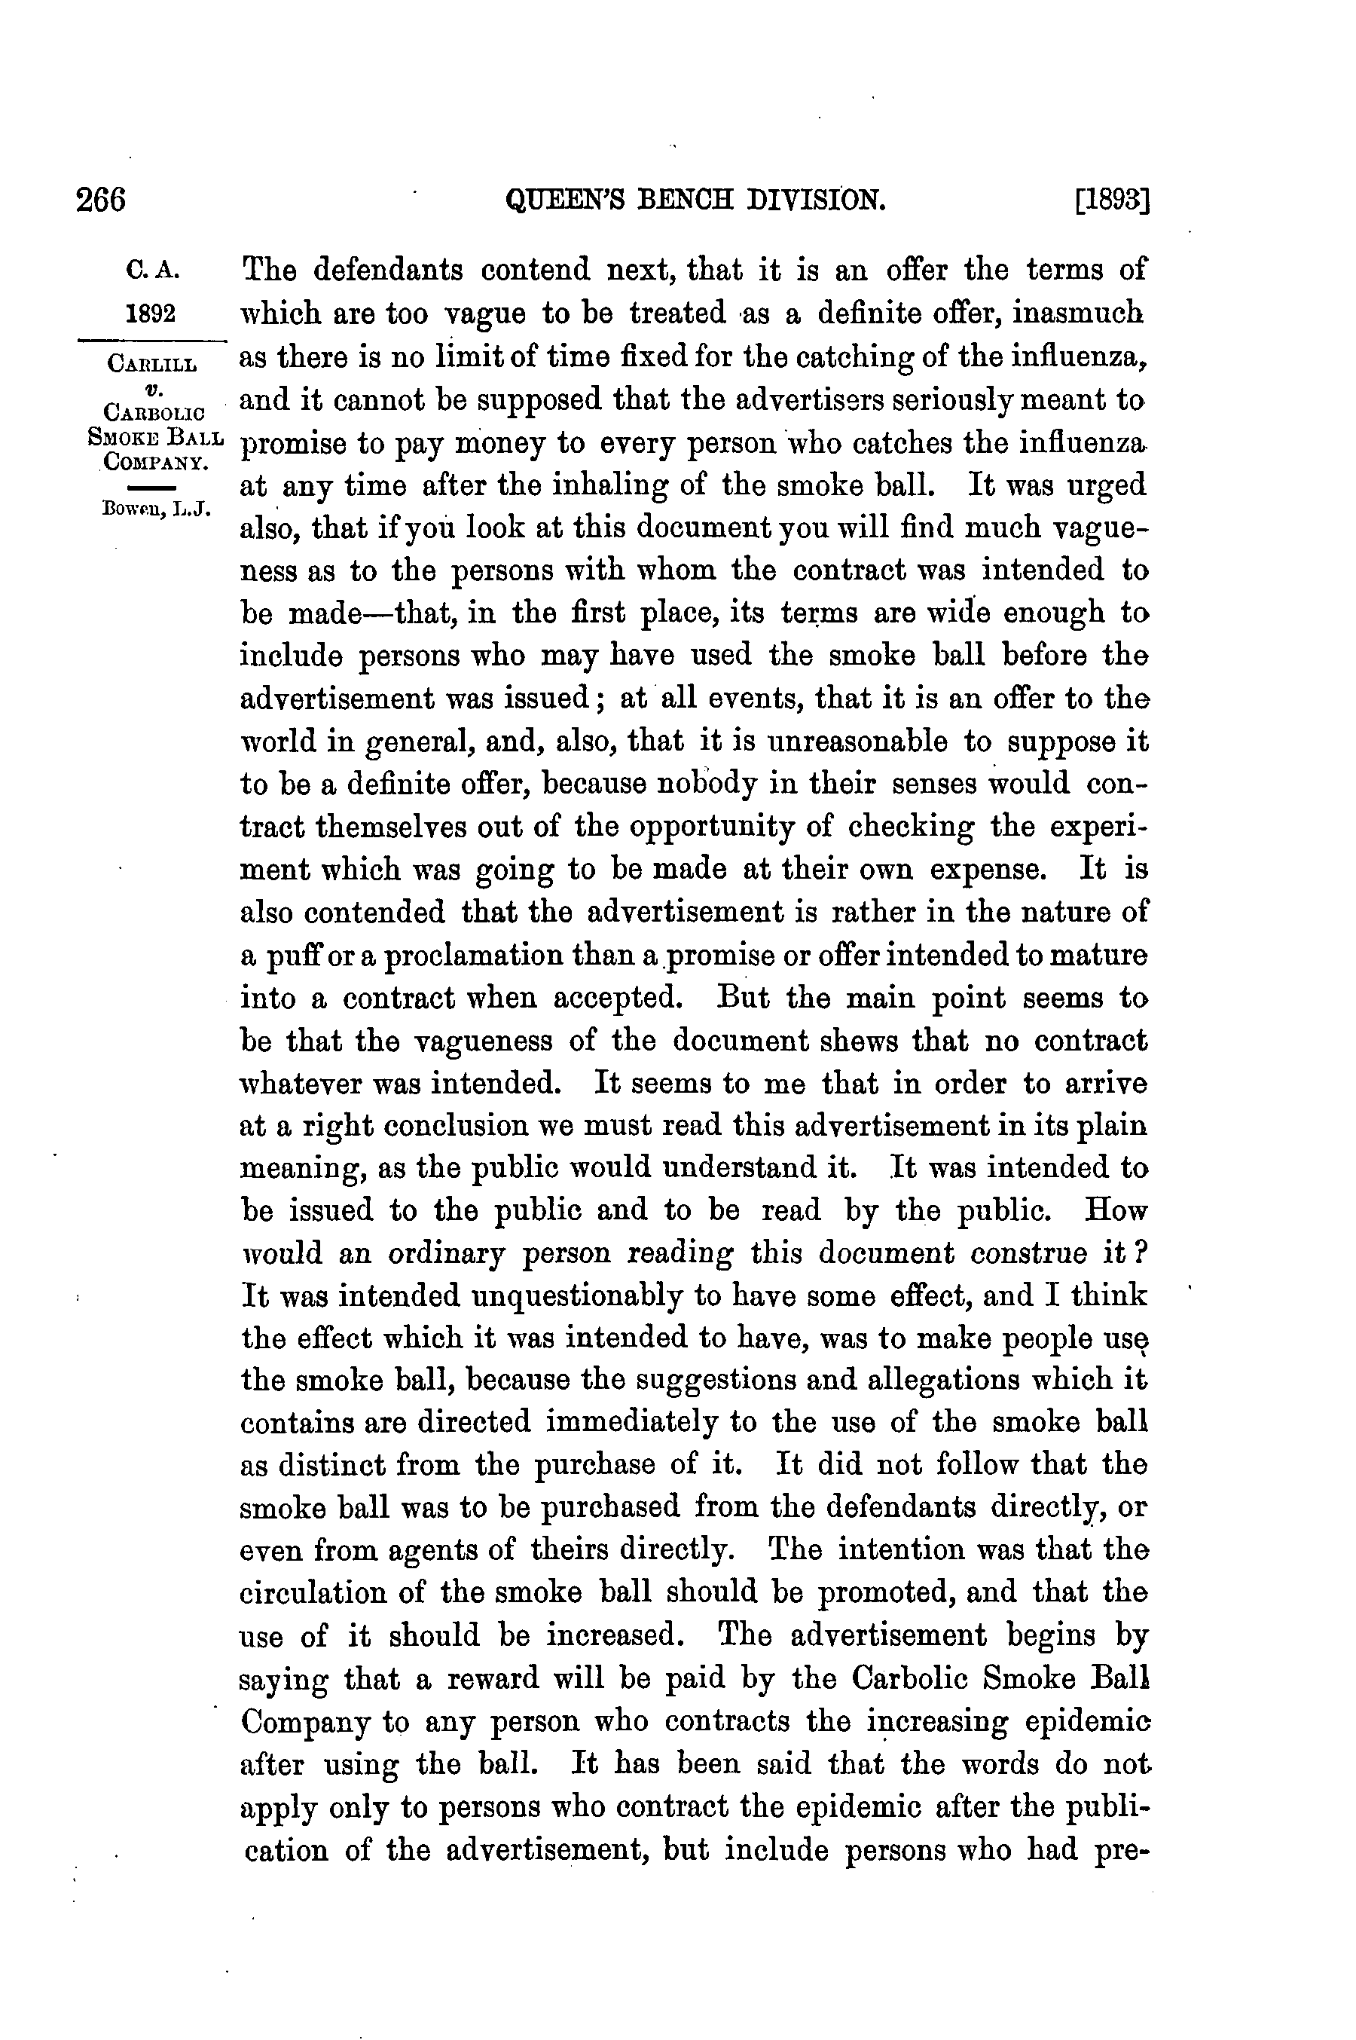

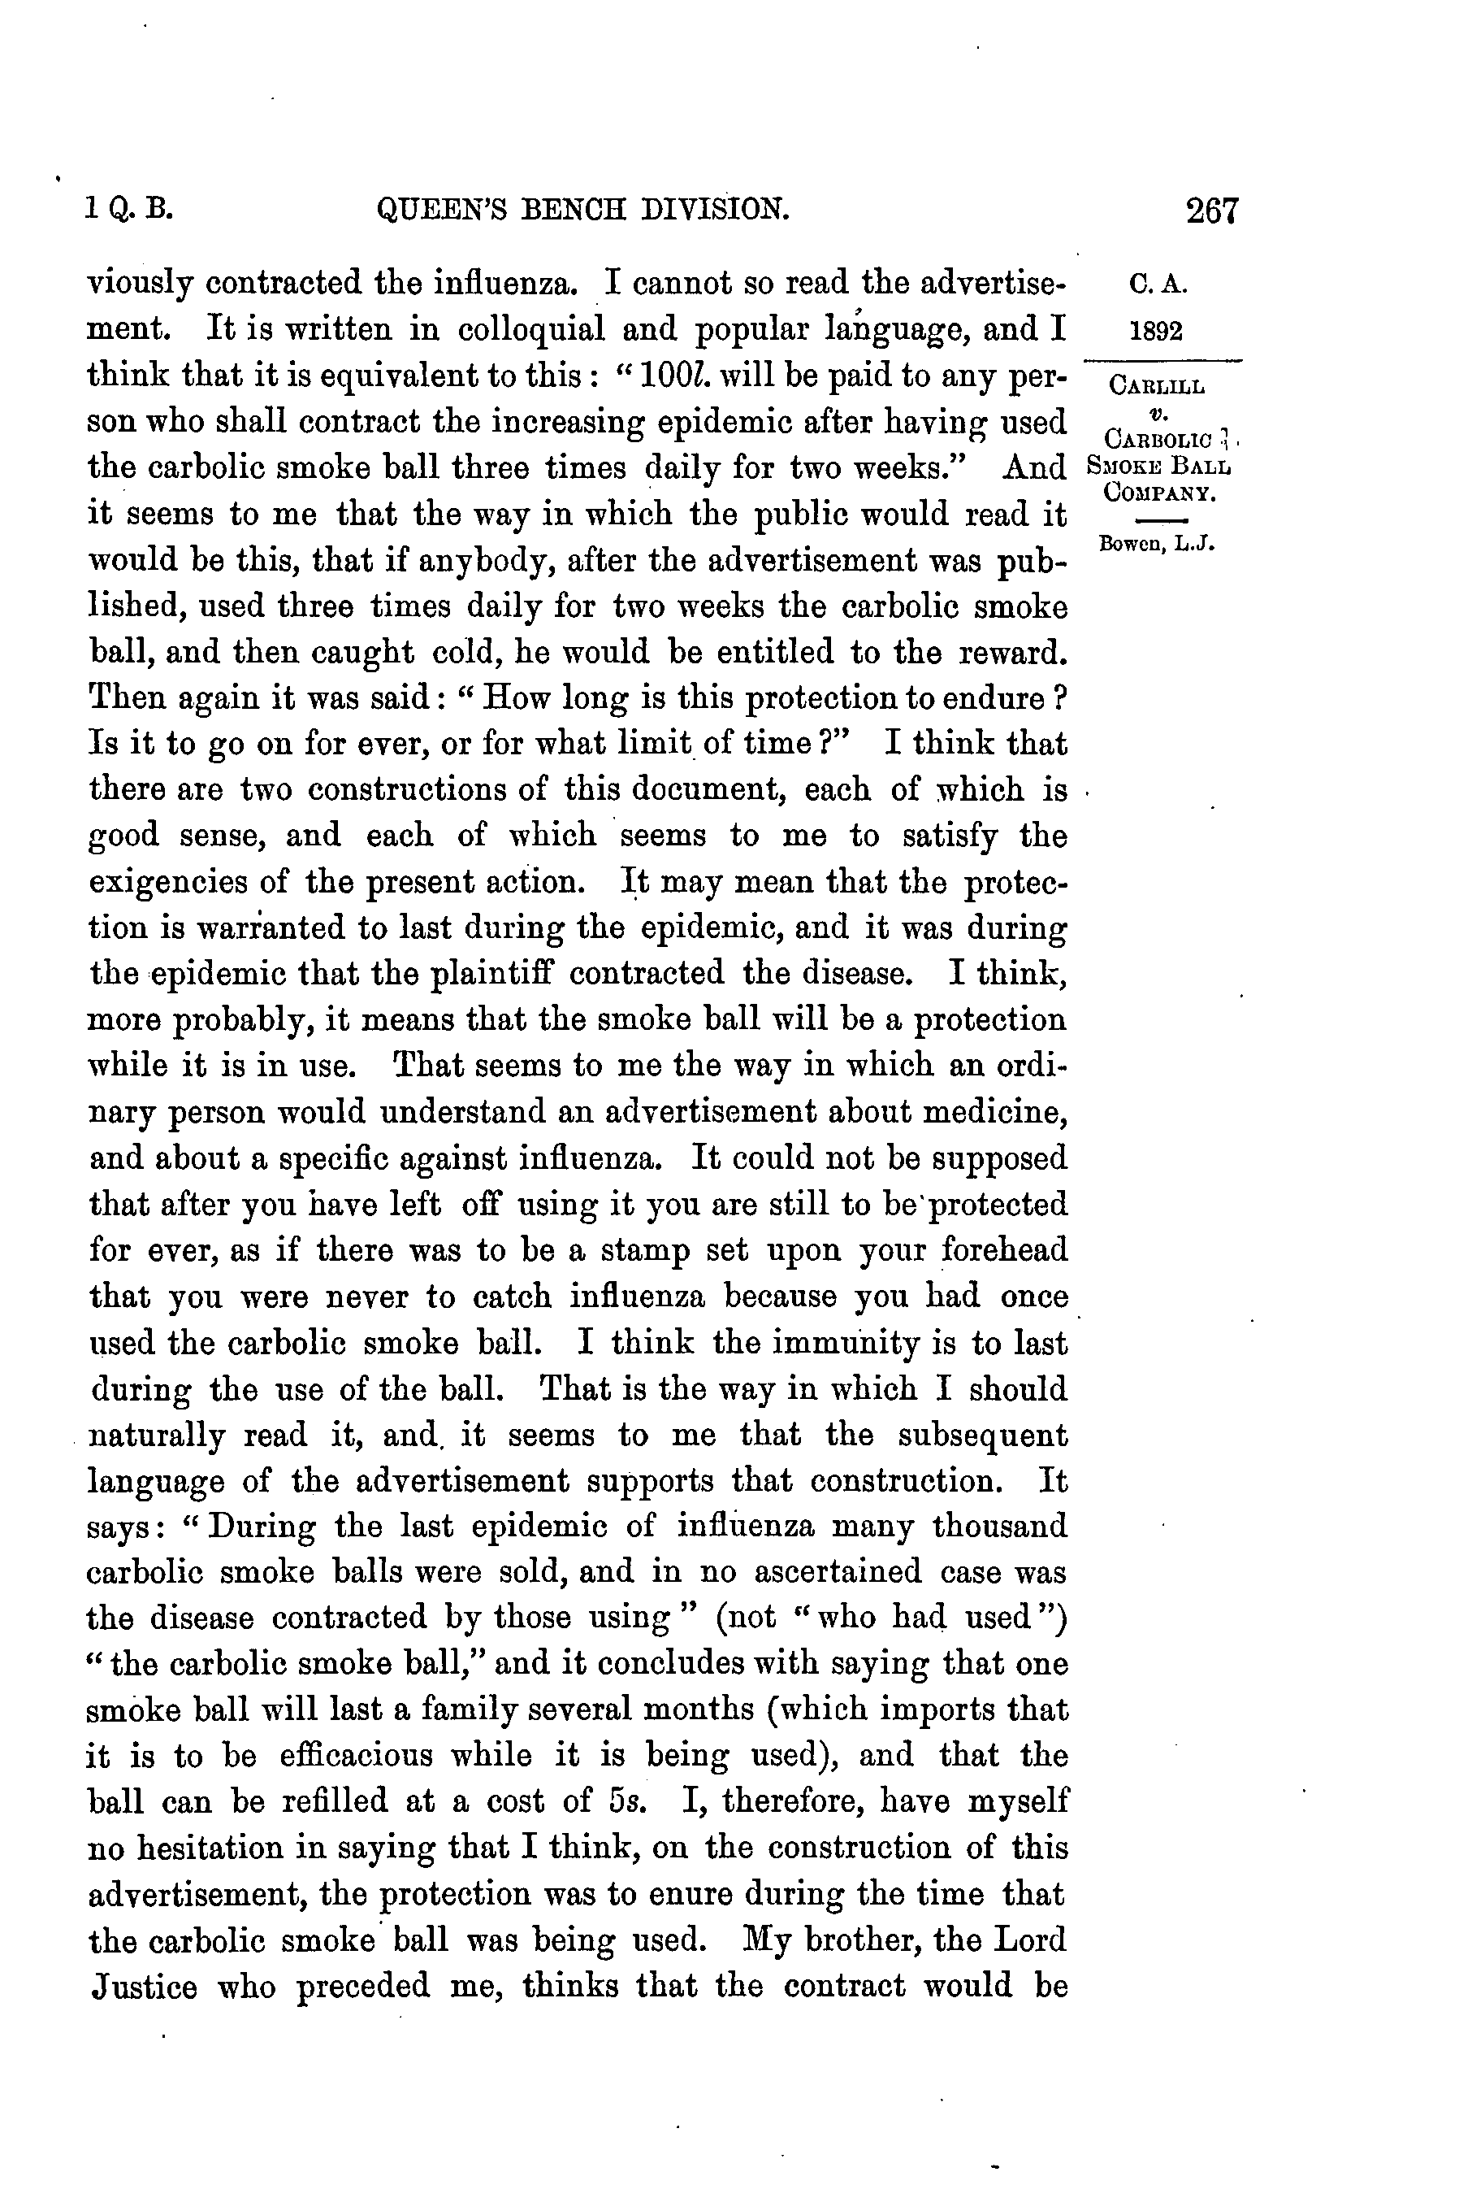

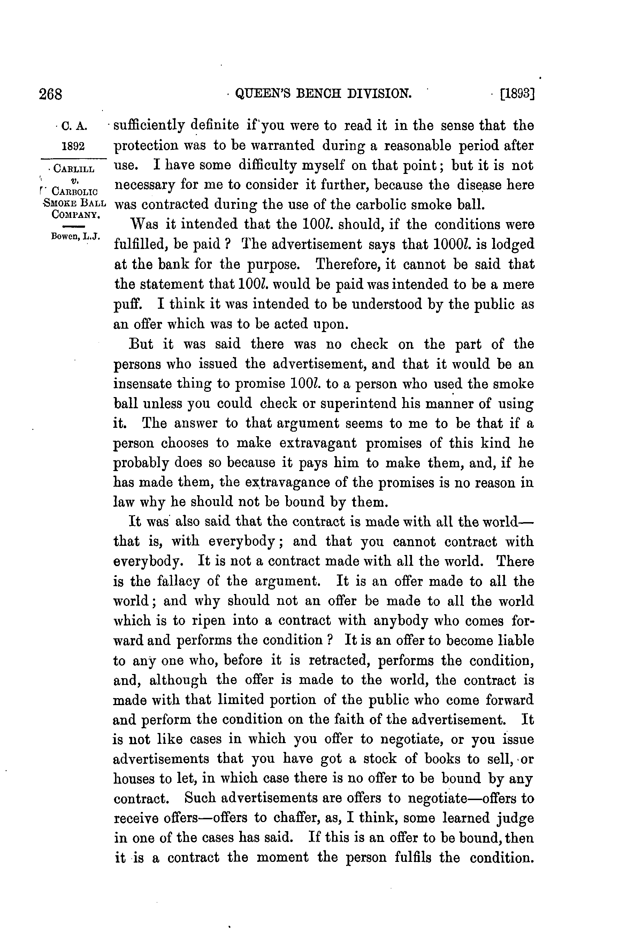

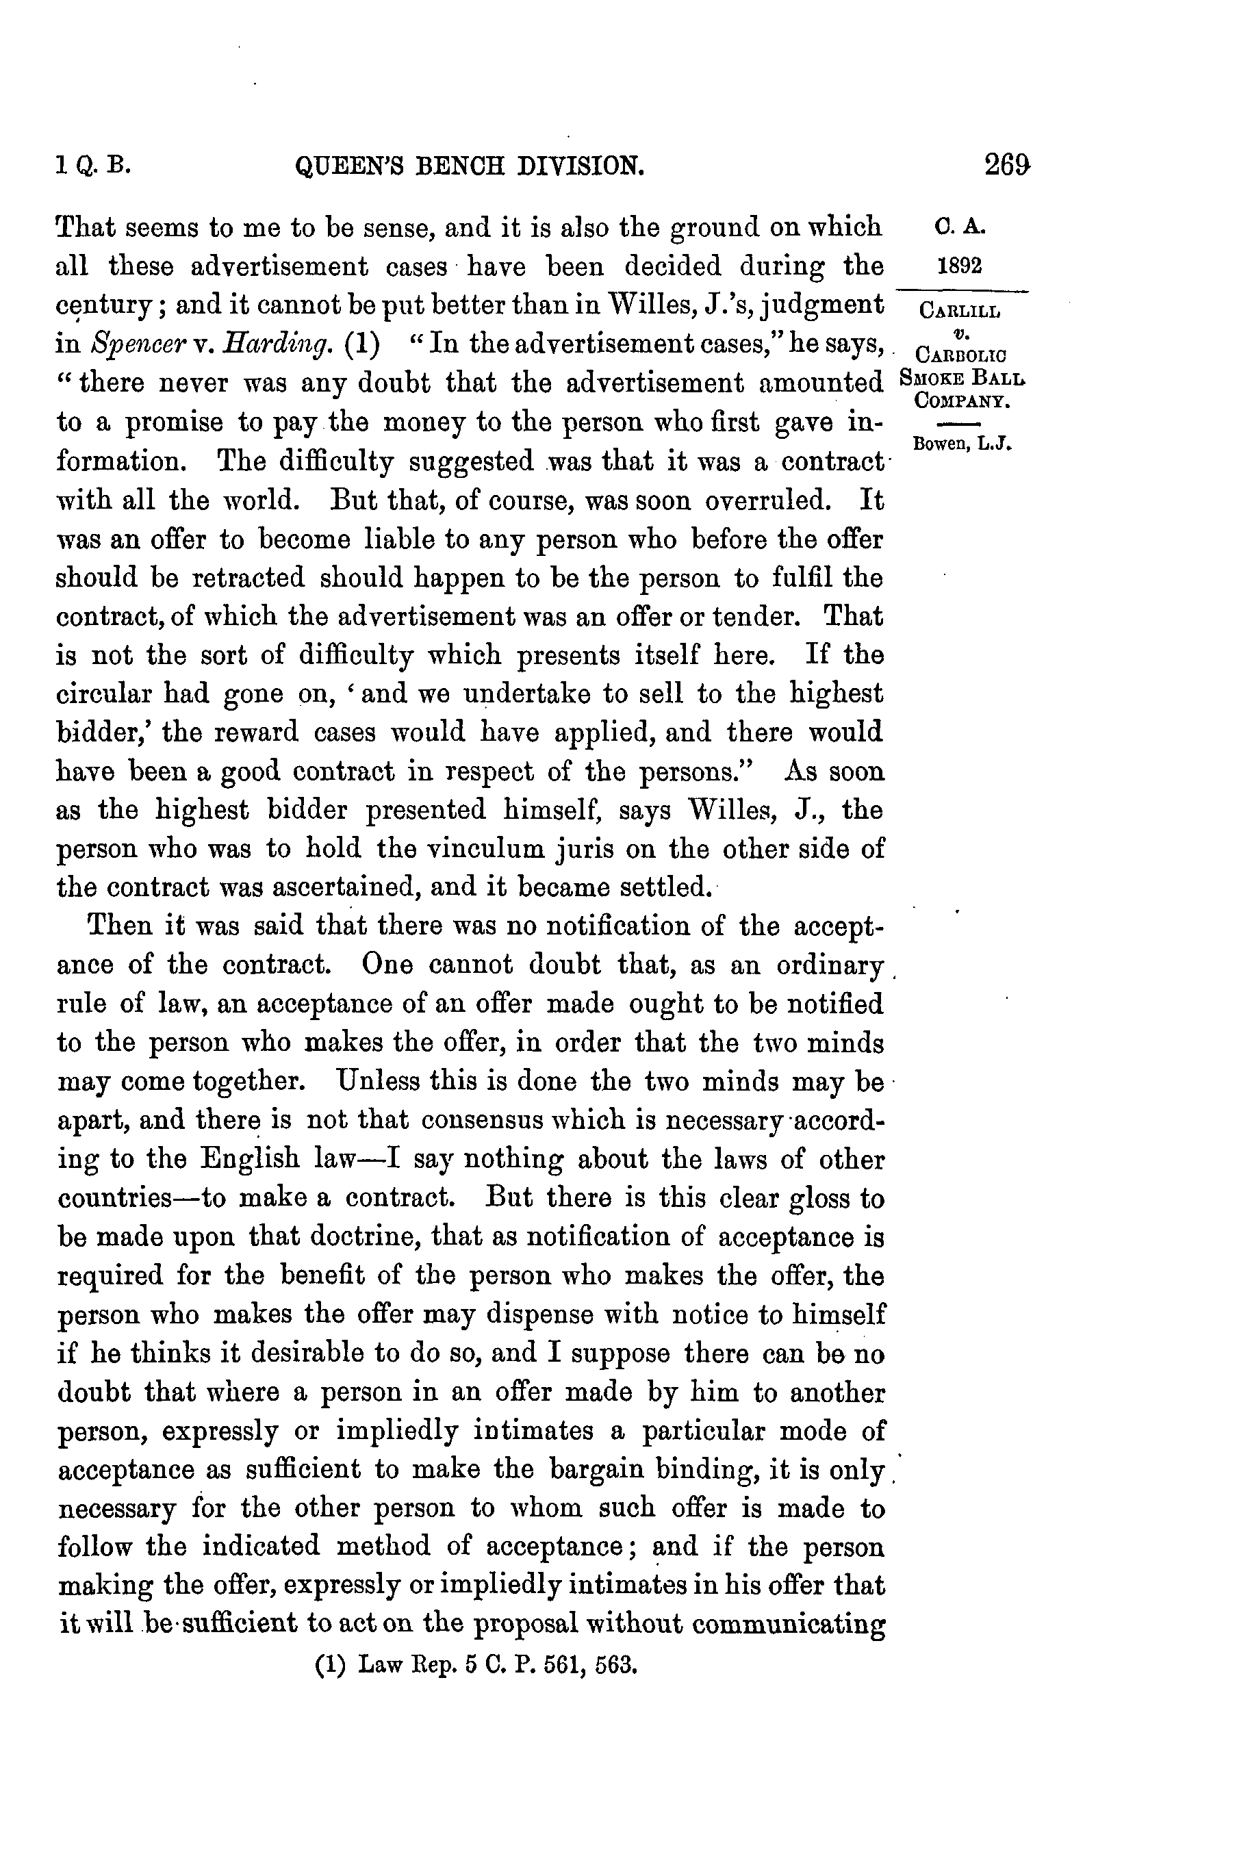

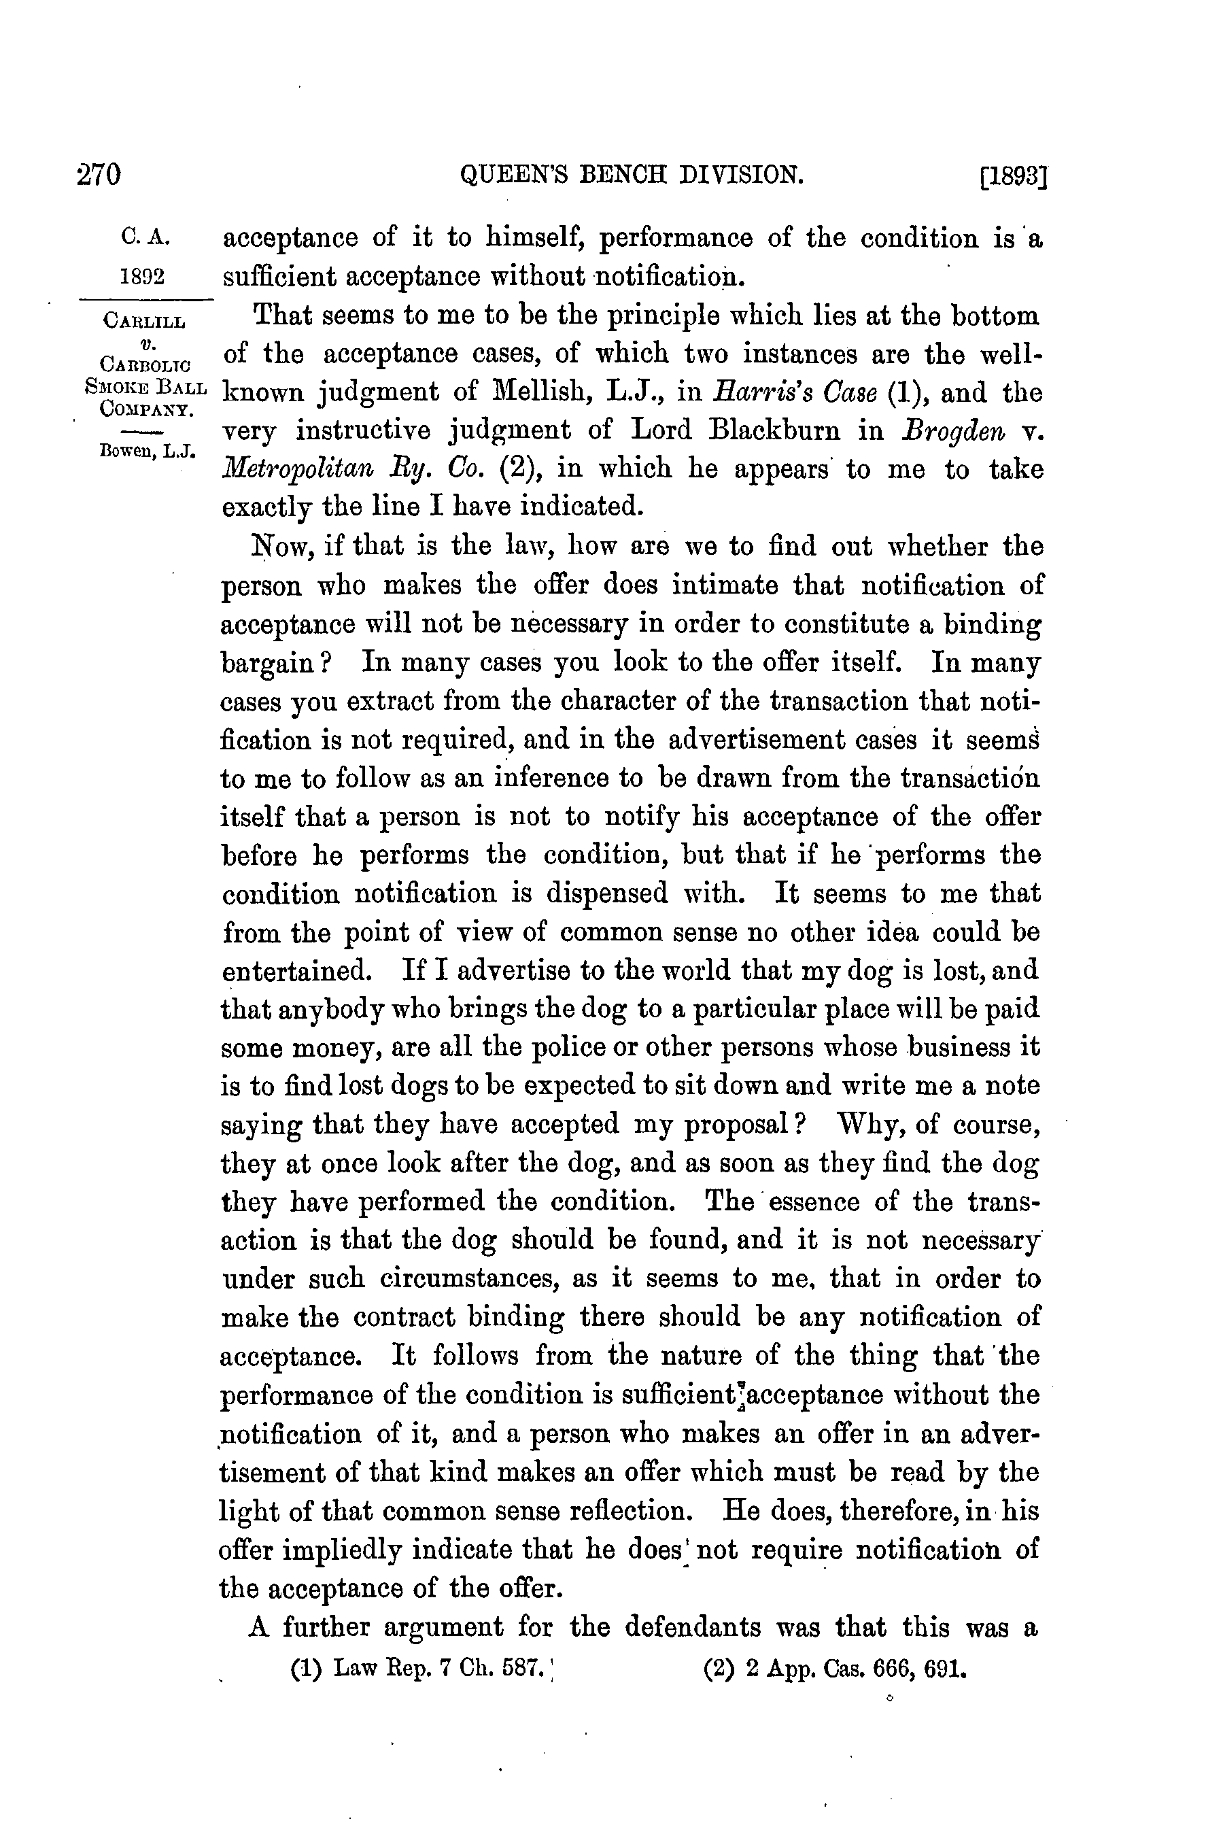

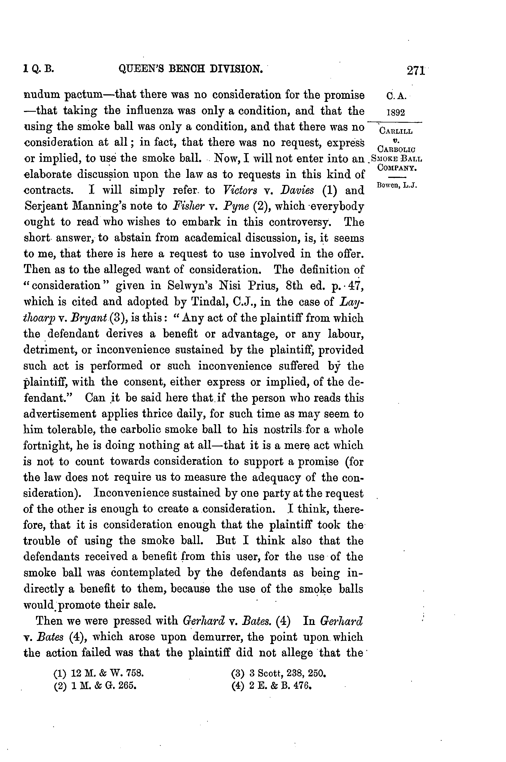

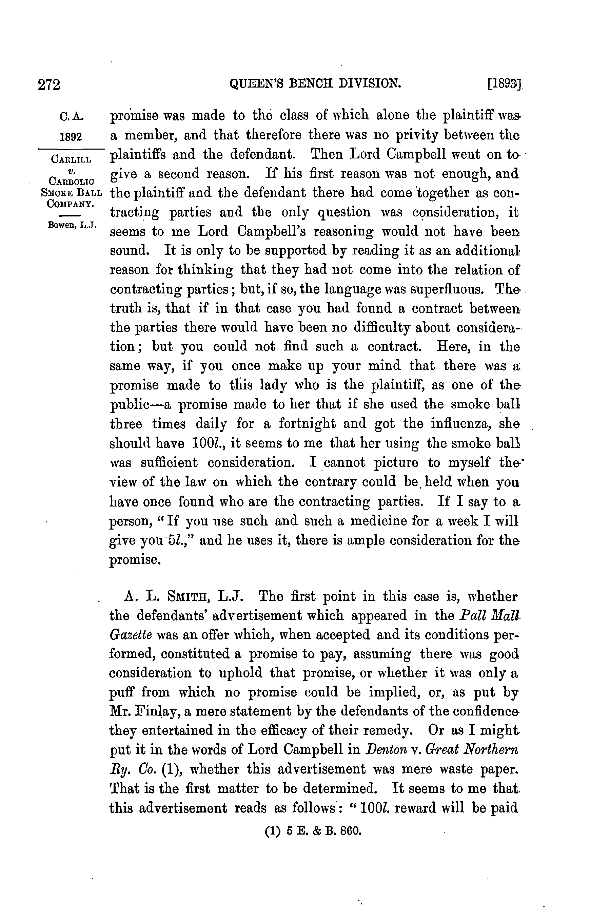

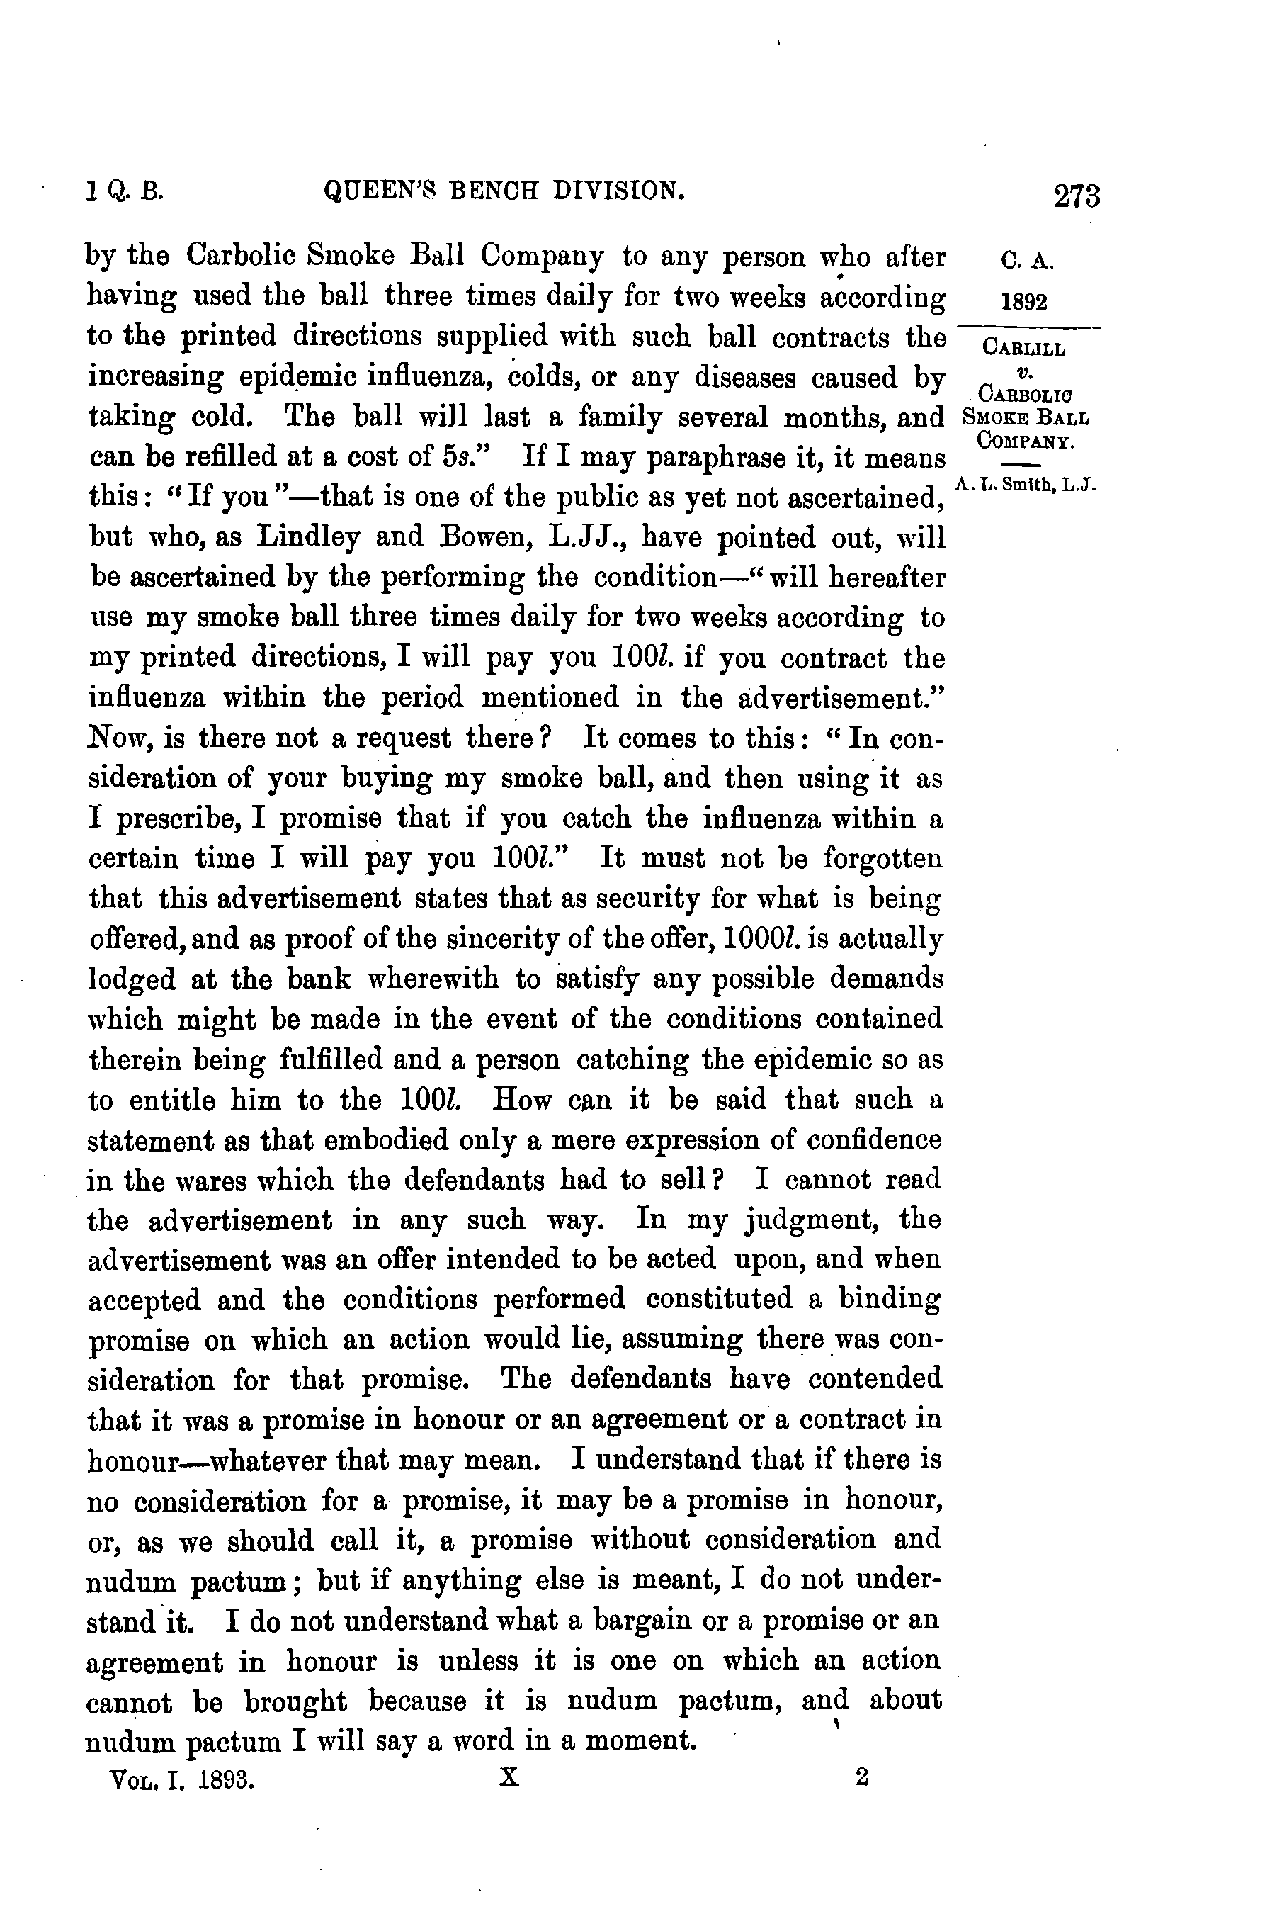

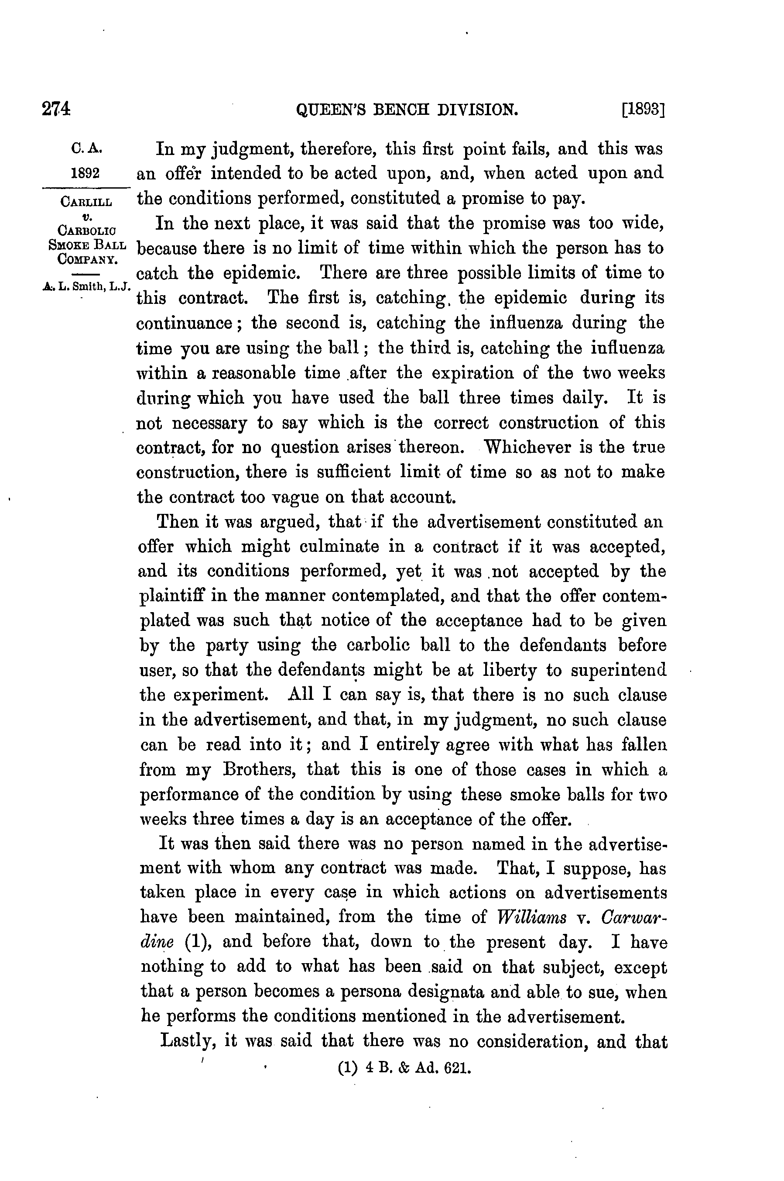

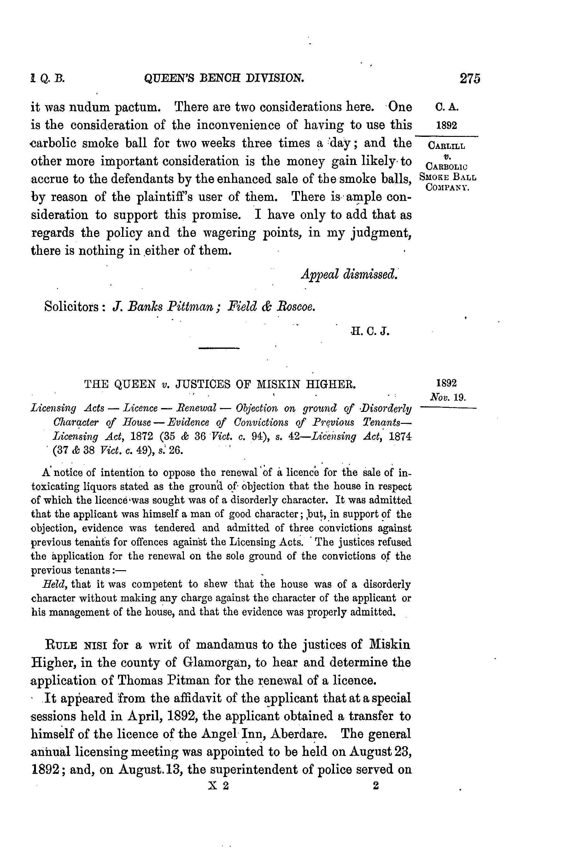

**--- END OF PART B ---**

1. This is fictitious case.